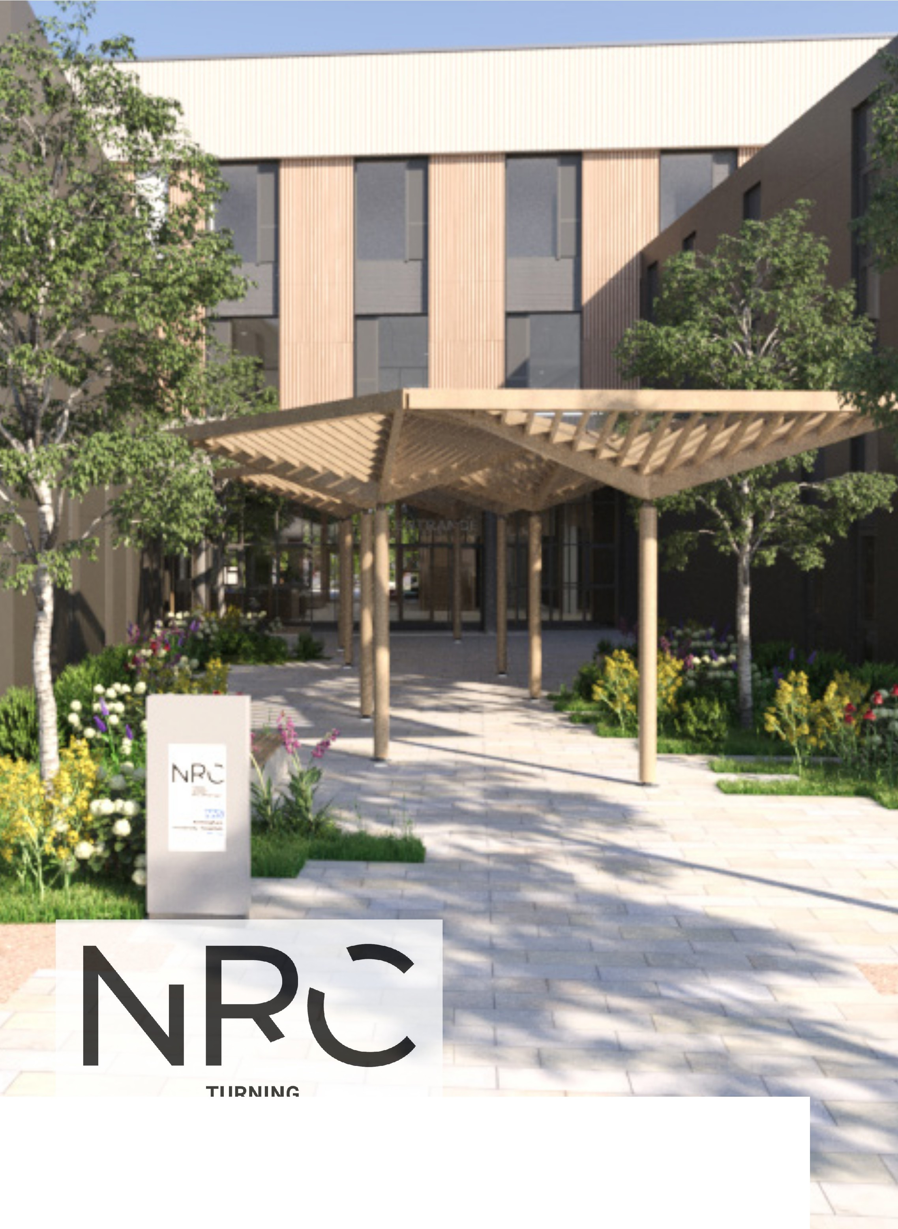

TURNING ADVERSITY
INTO OPPORTUNITY

What is the ambition?

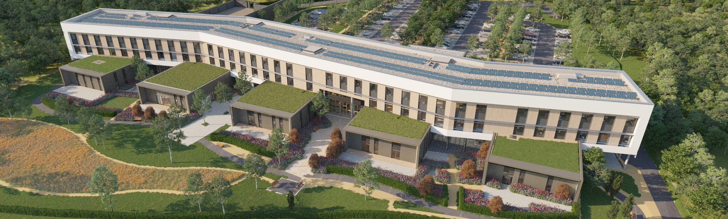
If you have a serious accident or illness in this country, the initial treatment you are likely to receive from the NHS will be second to none. Our interventions and expertise in responding to major and life-threatening injury and illness are acknowledged as outstanding.
3
Unfortunately, the same is not true for people who then require clinical rehabilitation. We fall behind many other nations in helping people to get back to fitness, to work and to leading meaningful lives.
When people who have the potential to regain their quality of life are unable to access
rehabilitation then this has a significant negative impact on the individual’s physical and mental health. Furthermore, growing numbers of people unable to access rehabilitation also creates a wider issue within our society as makes it more difficult for them to return to economic activity.
The National Rehabilitation Centre (NRC) will change this once it opens in 2025. It will
significantly improve rehabilitation for patients across England by delivering new ways of working and driving innovation. The regional clinical model which will be rolled out across the country will transform outcomes for patients.
It will provide the first national research and innovation hub, and training and education centre, which will push the boundaries of rehabilitation for individuals on their recovery journey.
This leaflet introduces the NRC and provides
a snapshot of its purpose, potential, and opportunities to get involved. We are looking for partners to work with us to further this ambition and become key advocates for the possibilities which lie ahead.

Origins - The Defence and National Rehabilitation Centre Programme
The NRC is part of the overall Defence and National Rehabilitation Centre (DNRC)
Programme which sets out to do two things:
First, to deliver a 21st Century successor to the Ministry of Defence’s former Headley Court facility in Surrey. This new Defence facility opened in 2018 and is now treating members of the Armed Forces.

Second, to create a National Rehabilitation Centre to provide clinical rehabilitation for NHS patients, as well as providing a national hub for innovation, cutting edge research and development and training and education.
A key benefit to the NRC is that it is just 400 metres away from the Defence establishment on the Stanford Hall Rehabilitation Estate, near Loughborough. This will allow patients in both centres to benefit from shared expertise, knowledge and facilities

Making the opportunity a reality

The government funded NRC building will open to patients in 2025. It is part of the New Hospital Programme.
The Nottingham University Hospitals NHS Trust
–home to the East Midlands Major Trauma Centre
– was selected to deliver the NRC programme and will both staff and run the facility once it
is open. NUH already provides the regional services for neurosciences, complex trauma and spinal surgery, so where patients subsequently require rehabilitation, they will be able to naturally progress to the NRC.
Meanwhile, the academic ambition for the NRC is driven forwards by our lead academic
partners Loughborough University and the University of Nottingham, alongside a consortium of 24 universities, all working collaboratively to push boundaries in rehabilitation research and education.
The opening of the NRC will mark the completion of the DNRC programme will see a significant proportion of the nation’s military and NHS rehabilitation medicine based on the Stanford Hall Rehabilitation Estate. The rehabilitation, innovation and education taking place on this site is expected to be of international significance which will generate interest in the rehabilitation profession for the next generation of clinicians.

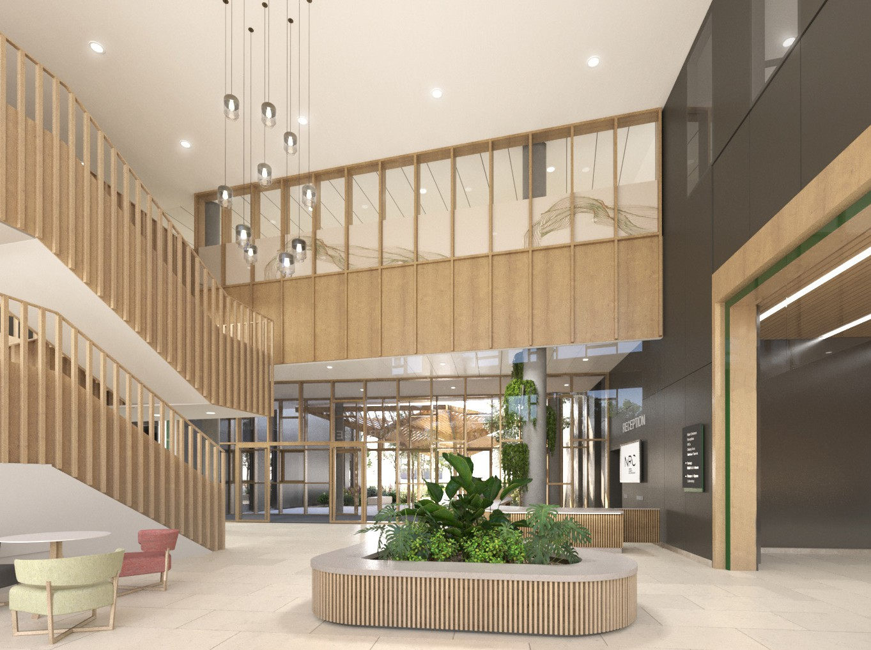



























Key facts
- Six out of 10 patients in England are not able to access the help they need for rehabilitation because there is not the capacity in rehabilitation services.
- If you accessed the defence rehabilitation service you would be twice as likely to return to work as currently in the NHS.
- The time from clinical research to implementation can be up to 10 years – at the NRC the
research will be happening on site and benefiting patients in real time.
- The ambition is to eventually establish a network of regional rehabilitation centres which mirror England’s successful Major Trauma Centres, as part of a hub and spoke model.
- The cost of a rehabilitation spell at the NRC will be £39,000, which then saves more than
£500,000 in health and social care costs for each person.

5
4

Where could the NRC lead?

In the near term, the NRC will have an immediate impact and make a meaningful difference to individuals’ lives. In the long term, it will be transformative.
Partnerships
The NRC is actively looking to develop partnerships with industry, third sector organisations, and professional bodies to push the boundaries of what we can achieve through intensive rehabilitation. Engineering, product design, materials, monitoring, technology and research will be brought together in an active space to generate solutions to issues facing real patients. Employers will also be welcomed to collaborate with the NRC to understand how they can adapt workplaces to support their employee returning to work. Within the NRC building there is dedicated space which has been specifically designed to welcome partners to work with us.
Partnering with the NRC comes with the following
benefits;
- Opportunity to work with world leaders in the
rehabilitation field
- Access to academics and clinical experts
- Minimum of quarterly visits to the NRC
- Opportunity to bring up to 10 guests per visit
- Visits can be up to half a day depending on nature of the visit
- Access to innovations space
- Opportunity to research with NRC patients and consortium universities
- Ability to showcase work on the NRC website and if appropriate on screens within the building
- Potential use of conference space which seats up to 50 people and break out spaces for showcasing work and hosting visits
- Communications support to announce the partnership via a press release and with media, in conjunction with your own PR/ Communications team
- Name checking in related and appropriate NRC press releases and social media posts to boost your organisation’s profile
Clinical rehabilitation
The NRC clinical model will provide a national Centre of Excellence in clinical rehabilitation. Early and intensive rehabilitation will transform how patients and their families can best shape their new life so that it is as independent as possible, includes both work and social activities, and enables them to maintain positive mental health.
The model is designed to be regional and aims to be rolled out across the country in the first five to ten years from opening. The NRC will bring together the very latest technology and best practice, setting a new standard for rehabilitation in England.
Research and Innovation
The NRC itself will be a unique space where rehabilitation research and development can be conducted at pace and with patients undergoing rehabilitation at the point of care. Combining clinical and research activities in one space is novel and will speed up the implementation of rehabilitation research into clinical practice and therefore benefiting patients in real time. The NRC offers a real opportunity to drive forward new rehabilitation technologies, including a dedicated space to test and develop tomorrow’s new treatments and techniques.
The NRC’s research work is well underway with the appointment of a national Research Director and significant grants already secured.
Training and Education
The NRC Training and Education Academy will provide a comprehensive offer for rehabilitation courses – both formal university-based education and NRC CPD-accredited courses – created to support the ongoing development of staff, and in
Maintaining momentum

Many of the essential elements to make the NRC happen are already underway:
- The state-of-the-art building is under construction
- Academic partnerships have been established
- Research Director and clinical leads are in place
- International scoping work and collaboration is underway
- Early stages of engaging industry partners who could benefit and play a part in achieving our
ambitions
some cases, relatives and carers. A combination of evening, weekend, summer schools and fellowship offers will combine highly-accredited courses with flexibility of access. In addition, the NRC will have a strong learning environment and culture, acting as a centre of teaching excellence, allowing rehabilitation practitioners to refine their skills or upskill where needed.

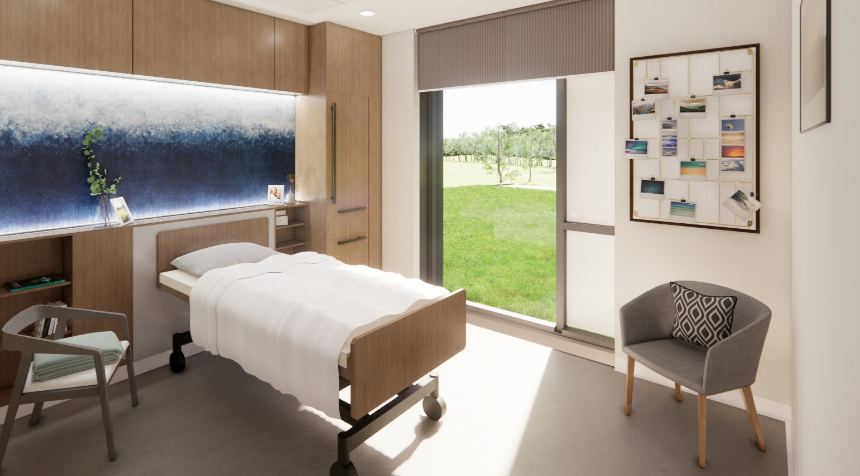

6
7

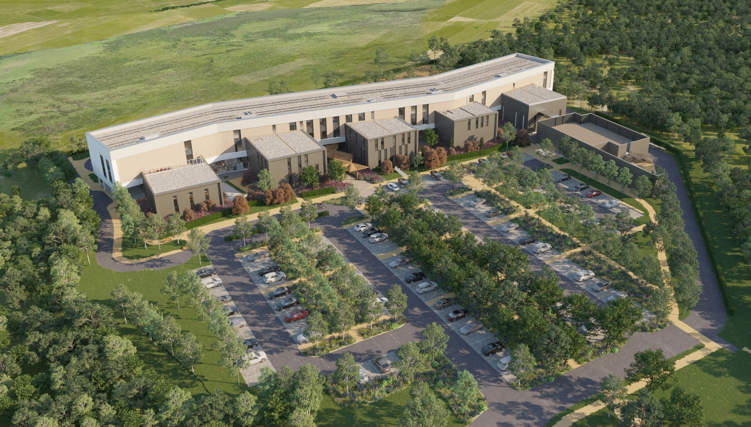
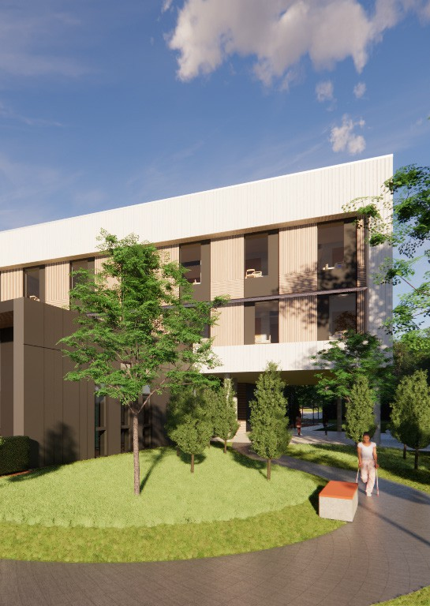
Opportunities
8
9
NRC PhD Projects

Seven PhD projects have been approved so far, and each will push the boundaries of clinical knowledge and current rehabilitation practice ahead of the opening of the NRC in 2025. Each one has been deliberately selected to represent a new area of clinical practice to influence practice at the NRC. Topics include the development of an evidence-based protocol for early mobilisation of spinal cord injury patients, and rehabilitation and education for the ‘body in the brain’ following serious injury.

Partnerships are of significant importance to the NRC. The NRC recognises that the way we treat and care for patients has the potential to change significantly in the coming years with developments in treatments, medicines, equipment and digital technologies all offering potential advancements in the way we meet our patients’ needs. Therefore, partnerships are not just important to us as a Trust, they are vital to our patients, our staff and our services.
Our ambitions for the NRC are significant – we want to transform rehabilitation nationally and internationally to ensure that as many patients as possible who suffer a life-changing injury or illness have the opportunity to live their life to the full again.
We are keen to work with prospective partners and explore options to work together for the benefit of our patients. We would like to hear from prospective partners who can add value and wish to be part of the NRC ambition.
Rehabilitation Technologies Network (RTN)
The University of Nottingham, in collaboration with Loughborough University, has been awarded
£1million by the Engineering and Physical Sciences Research Council (EPSRC) for a healthcare technologies NetworkPlus grant. The network, Next Generation Rehabilitation Technologies, will focus on developing advanced technologies which target both physical and mental health conditions. The RTS brings together researchers, healthcare providers, patient and user groups, industrial partners and supporting organisations (such as policy makers and charities) to develop a world-class research community and infrastructure for advanced rehabilitation technologies.

The case for the NRC is clear and compelling. If you would like to know more or to get involved, please get in touch.
nrc@nuh.nhs.uk

